Apocrypha of TESKAZ

Written by (**Disciples of Teskaz**)

Authors: Tobi Prais(st20226583), Cass Mephan (st20233132), Tom Jones(st20226222), Mario Battiston(st20234326)

Point of contact (Tobi Prais)

Date of publishing: 15th of December 2023

Version number: 1.0

|  |  |
| --- | --- |
| Fonts | |
| For | Fonts |
| Bodies of text | Rockwell |
| Headers | Bloody |
| Awesome title | Bloody |
| Headings | Rockwell |
| Sizes | |
| For | Look |
| Bodies of text | 10 |
| Headers | 24 |
| Awesome title | 48 |
| Headings | 20 |

Table of Contents PAGE

Revision history— 5

Game goals- 6

Game’s “high concept”— 7

Who, What, How? 8

Demographic— 8

What— 8

How— 8

Platform and Technical Requirements 8

Story overview— 9

Story Communications 9

Publisher concerns— 10

Legal considerations 10

Social considerations 10

Ethical considerations 10

Game controls— 11

Technological requirements— 12

Tools: 12

Title/start screen— 13

Game flowchart— 14

Loading screen— 15

Game camera(s)— 16

First Person Camera view 16

Other Camera-Uses 16

HUD system— 17

Character(s)— 18

Player metrics— 18

Player skills— 18

Player inventory tools (equipment, spells, buffs, and so on)— 19

Combat— 20

Power-ups/state modifiers 20

Health— 21

Achievements— 22

Collectibles/object sets— 22

Game progression outline— 23

World overview/level select/navigation screen— 26

Game levels— 27

Mechanics 28

General enemy rules— 29

Bosses— 29

Boss Behavior 30

NPCs— 31

Minigames— 32

Monetization— 32

Downloadable content— 32

Teskaz Black Friday Massacre – 32

Music and SFX 33

Other screens— 33

Appendix(es) 34

Concept art 38

Beast 38

Posters 41

Summoning circle 44

# Revision history—

02/11/2023- GDD start.

06/11/2023- Loading screens, posters and fonts

09/11/2023- Discussions on game beat map, game flowchart, ethical considerations

11/11/2023- game flowchart, world overview, inventory system, health system, combat.

15/11/2023- general meeting on progression, concept art (beast/boss), music and SFX list, HUD elements, document layout refreshed.

16/11/2023- Legal, ethical and social considerations. Publisher concerns and mitigations.

22/11/2023 - Game Levels added, minutes added, section on mechanics, production plan.

23/11/2023- Final additions

# Game goals-

* Clean up and restock the hit superstore Teskaz after hours.
* Make sure all the customers have left.
* Avoid The Beast.
* Survive until the store opens.
* Horror game Achievements.
* Horror narrative.
* First person 3D Low poly horror art style.
* Discover secrets.

## Game’s “high concept”—

A gritty low poly 3D horror that is atmospheric and immersive in its level design and mechanics. The high concept is to enthrall players in the world and levels of Teskaz as well as absolutely terrify the player with the horror elements that are lathered throughout the game. In Teskaz the player will take control of the character “Alex”, a worker at Teskaz Superstore, who takes up a shift restocking shelves the night before Black Friday.

The Beast stalks and hunts them. Can Alex survive- and keep their job in the process?

# Who, What, How?

## Demographic—

Expected PEGI 18+ game, horror narrative, horror subject matter, a lot of gore/body horror.

Teskaz is a game for indie horror and horror fans alike especially horror fans that appreciate a low poly 3d indie style horror game. Fans of vintage horror films might also be particularly drawn to Teskaz almost vintage slasher feel when it comes to the style of the game.

## What—

Teskaz is a first-person horror game with low poly 3D graphics set in the hit supermarket Teskaz. Set the night before black Friday you play as Alex, a desperate employee who took up a restocking position. As the night progresses strange events unfold the horrors of Teskaz. Gameplay: Explore the Teskaz supermarket, clean areas with the tools at your disposal, restock shelves, escort rogue NPCs and escape from The Beast hunting you!

## How—

* An all-new spine-chilling horror game with a unique setting with a horrifying low polygon art style. Clean, restock, run, hide and survive.
* This creature has never been seen before, a new and deadly horror.
* Immersive atmosphere with simulation like elements.
* CRT filter that will give the game that semi vintage feel which will complement the
* The game will be prototyped and created in the Unity game engine.

## Platform and Technical Requirements

**Platform**: PC

**Type:** Single player horror game (no multiplayer functionality)

**Minimum Technical requirements:**

OS: Windows 10

Processor: Intel i3 @ 3.2ghz

Memory: 8 GB RAM

Graphics: a modern dedicated graphics card

Storage: 1700 MB available space

Game will not be very demanding in terms of technical requirements due to the low-poly art style and only having one level.

Gameplay types:

Stealth: Heding in designated safe areas in the map that are usually a bit darker to obscure the “vision” of The Beast.

Investigative: Explore, collect and uncover the mystery of Teskaz

Escape:

Simulation: Cleaning up messes with cleaning equipment (mops and broom) and

# Story overview—

You are Alex, a Teskaz Employee who has been scheduled for a late-night re-stocking shift the night before Black Friday.  As you re-stock shelves, clean the floors and escort rogue customers out of the building you start to notice some unusual activity around the store. As the activity increases you start to notice a lanky figure stalking through the store.  As the figure’s interest turns towards you, you must run and hide to escape while still completing your job.

## Story Communications

* The story will mostly be communicated through in-game text boxes (character’s inner thoughts and dialogue) and notes. There will also be a beginning and end cutscene.
* Notes scattered throughout the levels of Teskaz.
* Inner thoughts displayed via text boxes.
* Dialogue displayed via text boxes.
* Specific events that take you through the game.
* Visual storytelling coupled with audio ques.
* Beginning and end game cutscenes Visual/Text.

# Publisher concerns—

## Legal considerations

* Violence, gore and bad language in video games and age ratings.
  + The game will be age rated by the Pan European Game Information group to mitigate any audiences who are not of age to view the games contents.
* Legal Copyright issues pertaining to our games setting inspiration Tesco Extra in Llandaff, Cardiff and all the products/brands that are presented in the store.
  + The game is being made in the UK, and so will follow UK law regarding copyright. For this reason, the game’s location is intended solely as a parody of The existing brand Tesco (*Copyright, Designs and Patents Act 1988*), and products within are omitted.

## Social considerations

* Caution should be taken regarding already existing mythology when conceptualizing The Beast. Although it is not illegal to use monsters from mythology since most mythological creatures were ussually written more than 75 years ago however regarding cultural/mythological appropriation of other cultures mythological creatures could be seen as disrespectful if the creature, spirit or entity is portrayed in a way not faithful to their respective cultures.
* The portrayal of certain classes of people being portrayed in a certain way could be perceived as too political could turn away some publishers from not wanting to promote any socio-political messages.

Mitigation:

* “The Beast” is deliberately conceptualized to have zero connections to any specific real-world culture.
* Politics can be viewed in every media and video games are no exception. Our game won’t be trying to make any clear political statements this will be don’t to not alienate any part of the game’s audience.

## Ethical considerations

* Representation and stereotyping of characters within games.
  + There are very few characters within the game, the Player Character, some lost customers, and The Beast. For this reason, consider representation is not essential – however any human characters that are made will attempt to diversify the game, without conforming to stereotypes.
* Actions within the game that could be considered unethical
  + As part of making the game, decisions have to be made regarding whether or not to allow the player to make actions that could be considered non-ethical, especially in terms of NPCs that could be considered ‘Innocent’ – for example, the old lady character. Sicart (2009) suggests that the interaction between game rules and the world of the game has implications on the ethics the game holds. It is this line of thought that makes the decision to compartmentalize the ‘innocent’ NPCs away from The Beast- their appearances take place before it begins to hunt.

Game controls—

Provide an overview of the controls. List specific moves the player will be doing, but don’t go into detail on the actual moves … yet.

**The controls –** Keyboard and mouse.

- WASD for directional movement

- Mouse for camera direction

- Shift to run

- Control to crouch

- Left Mouse buttons to interact, pick up, put down, etc.

- scroll wheel and 1 &2 to switch between inventory items

* Left hand inventory scrolls between items, scroll wheel up.

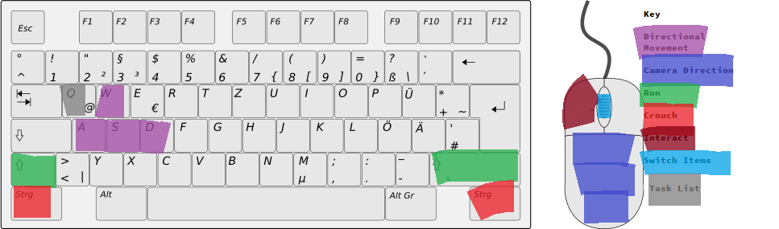

Technological requirements—

Tools:

Teskaz will be made with the multi-platform game engine Unity, the scripting languages that will be used are C++. 3dsMax & Blender are the tools that will be used to model the low-poly models of Teskaz. Other tools like GIMP the freeware imaging software will be used for texturing and other processes to help modeling. Alternatives tools, Photoshop for the same functionality as GIMP but arguably has more resources.

**Rational:** Unity is a well known well supported indie game engine that has been the engine to release many successful games. Indie horror games are no exception.

Two similar, and popular, games – *Darkwood (*Acid Wizard Studios, 2017) and *Slender: The Arrival* (Blue Isle Studios, 2013) - are also made in Unity. These games show how diverse and useful the unity engine can be in making successful indie horror games.

3dsMax is an industry standard 3d modelling tool and is a great tool to create and export models into game engines with. Blender is another great tool for hobbyist 3d modelers and is slowly being more adopted by more game developers especially indie developers.

The key technical features of Teskaz:

* + - NPC pathfinding and AI that will be implemented for both the escort NPC’s and most importantly for The Beast and potential enemies.
    - Lighting in the level and the game environments and how the flashlight item will interact with these environments.

Building the game and its mechanics in a game engine to test and optimize. Research will have to go into enemy/npc ai as well as pathfinding for ai.

# Title/start screen—

New Game – Overrides any existing save and starts the game from the beginning.

Resume – Resumes any existing save.

Settings – Where the player can adjust graphics, sound and accessibility settings options.

Credits – A list of everyone who developed the game and the jobs they had.

Exit – Closes the game.

Game flowchart—

Show how all the screens from “title/start screen” to “game over” connect with each other.

# Loading screen—

The loading screen displays an ad for the game-central Corporation ‘Teskaz’. These will be deliberately quite odd and off-putting, to aid in worldbuilding and give the player a sense of unease. Some examples of this are below.

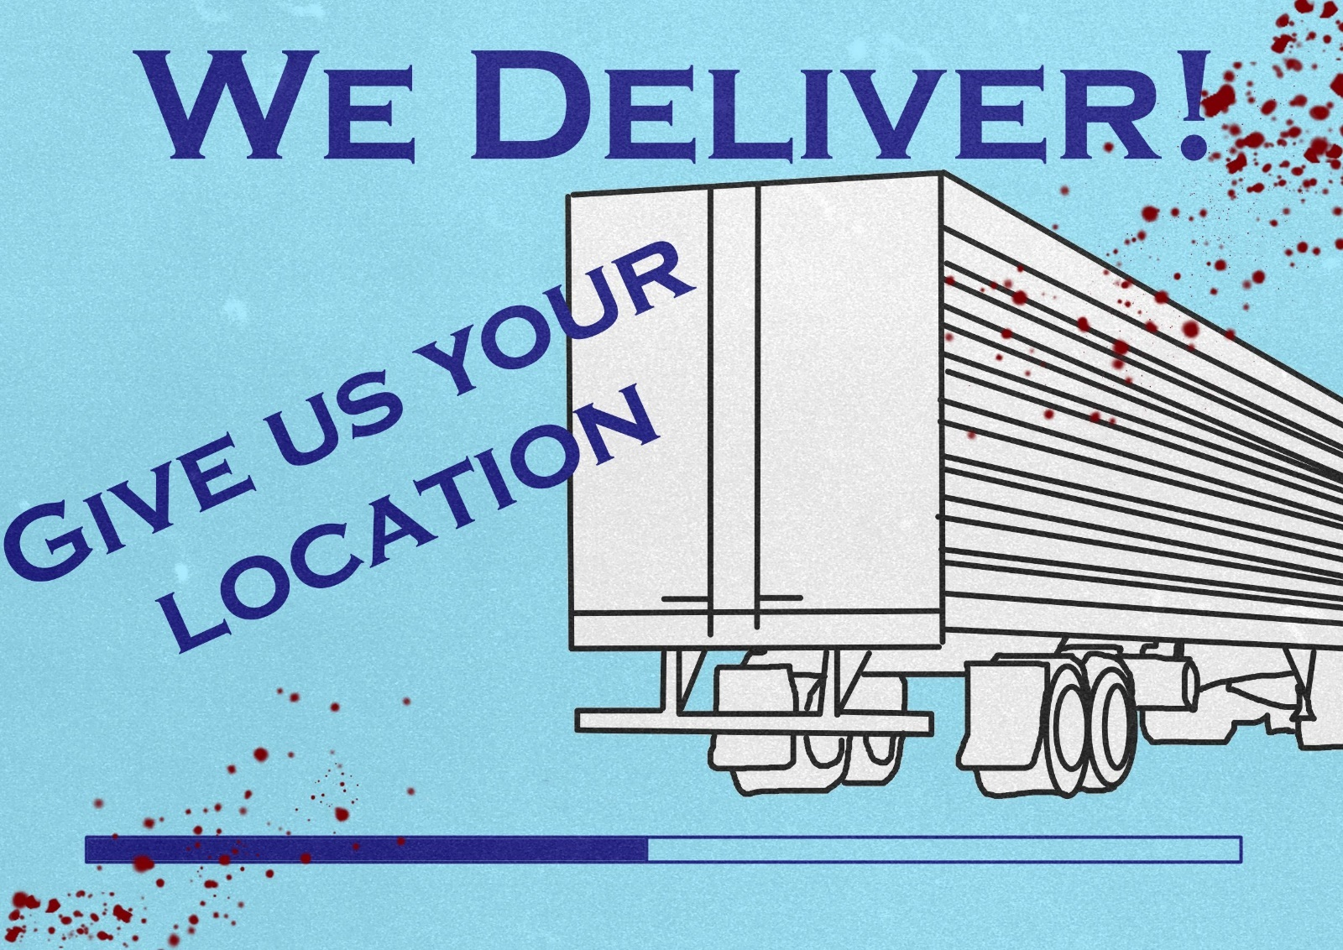

# Game camera(s)—

## First Person Camera view

The game uses a first-person camera, that follows the mouse to control and explore the surroundings. The camera is locked to the player character and will not pan away from the camera. The player character will never see the player model besides perhaps some appendages of the character model such as hands where appropriate. The player is the camera and will experience the world in this first-person camera view.

## Other Camera-Uses

* Cutscenes: There will be different camera positions for cutscenes and specific events that progress the story.

HUD system—

Important objects- Task notes and the tasks have faint outlines (Yellow, or another light color). These outlines appear when the object is within a certain range of the player, to make sure they don’t miss Important parts of the game.

Examples:

Managers note (Information on your jobs for the night from your manager);

Reduced Section (an area you must restock)

Pentagram Stain (must be mopped up)

These three examples cover the three main uses for this HUD mechanic – to prompt player interaction with important information, to guide players to task areas, and to let players know what items can be interacted with.

Task list – the player can check their current ongoing tasks via use of a key (Default Q) that brings up a display of all their tasks, this display is in the style of a notebook page and can have four types of writing displayed on it

* Basic tasks- these are displayed at the start of the game, when the list is unlocked (excluding the escort missions). Written in black.
* Basic Tasks (completed) - similar to the first but crossed out after player completion of the connected task.
* Beast Tasks – Tasks given mid-game by The Beast. Similar in concept, but much less mundane and more weird/creepy in nature. Written in red.
* Beast Tasks (completed) - Crossed out, for after the connected task is completed.

Character(s)—

The player character is called Alex, a Teskaz employee. Both Customer NPCs are strangers to Alex. Ganbold is Alex’s manager they have a friendly but strictly professional relationship.

**Character: Alex (Player Character)**

**Weight:** 165 lbs., **Height:** 5’10 ft,

**Physical characteristics:** Alex is in Teskaz is dressed in the very “fashionable” Teskaz employee attire sporting its classic Teskaz dark blue and light blue.

**Character Description:** Alex is the player. Alex is a self-insert character who the player can see themselves in and use as the vessel to experience the game.

**Character: Manager Ganbold**

**Age:** 42, **Weight:** 180 lbs., **Height:** 6’2 ft, **Gender:** Male

**Physical characteristics:** A tall man with a cheery demeanor which is juxtaposed to his rough and rugged facial features. Long black hair that is often tied in a bun.

**Character Description:** A 1st generation immigrant from Mongolia.He has lived most his live in the town. Ganbold has established a good live here. He is the Teskaz’s newest manager and is very well liked by the staff for his cheery attitude and his understanding nature. He run’s Teskaz dayshift hours and is experience in retail, customer service and management. He often also helps with night shift operations to help the nightshift manager.

**Relation to main character:** Ganbold is Alex’s manager.

Player metrics—

**Alex (Player Character)**

**Age:** 20, **Weight:** 147 lbs., **Height:** 5’7 ft, **Gender:** Female

**Movement:** Slow methodical movement where every step will make an in-game sound.

**Combat:** As previously mentioned, combat is merely having the mop/broom item equipped and looking at The Beast to stun them. The mop and broom will have a trigger distance of 1 to 2 meters in front of the player this will trigger the stun.

**Health:** The player only has one life and if The Beast catches up to them then the player will die, and this will result in a game over screen.

**Player death:** The animation for death in the game will be a red ring around the players view and them falling followed by a death sound and then a cut to a game over screen.

**Idles:** Since the player is experiencing the game in first person, they wont see the player characters idle. A very subtle idle will play if the player is stood still for a few seconds once the player starts moving again the player will just shift back into the regular walk speed and flow.

Player skills—

The player can sprint and hide to avoid the creature. Otherwise, they can do their job where applicable.

* Sprinting/running: This will increase the movement speed of the character making them faster in game and will aid them in doing tasks quickly and running away from The Beast.
* Hiding: This will allow the player to hide from The Beast once the player is out of The Beast’ss line of site either via out maneuvering, out sprinting/running or a combination of both and hiding in a dark spot in the store.
* Job Tasks: The player has the skill to pick up tools (brooms/mops) or products (any aisle product) and activate them on their required spots triggering them and doing the job task. This will be automatic ore will be accompanied by a animation to display the task being done.
* Stun: When in chases with the beat the player if they have a mop equipped can stun The Beast.

# Player inventory tools (equipment, spells, buffs, and so on)—

The player will have two set inventory slots. The left and the right hand. Below presents the items these hands are allowed to use and what they do.

**Left-hand** (Multiple items can be stored in this inventory slot and can be scrolled to using the mouse wheel):

* **Flashlight:** The flashlight is used to light up the dark areas in the level.
* **Keys:** There will be several keys that open certain doors to reveal new areas.
* **Collectables:** There will be several collectables in the form of comics littered throughout the levels of Teskaz and they will give players an incentive to explore Teskaz.
* **Notes and Audio tapes:** These items give more of the story of Teskaz and are completely optional to players who want to get more into the story/world of Teskaz.

**Right-hand** (Items are stored in inventory one at a time, no multiple items):

* **Cleaning equipment:** Mops, brooms and chemicals are the three items that will be used to complete the cleaning tasks throughout Teskaz and defeat the horror of dirty floors and services.
* **Store products:** Whatever is on the store shelves can be found in the stock room and youll need these items to be able to complete restock tasks.
* **Brooms/Mops:** Although Brooms and Mops fall under the cleaning equipment, they are also both unique because they can be used to defend yourself against The Beast that lurks through the aisles. They are used as a one-time repellent (after use it breaks) to stun The Beast and run!

# Combat—

In Teskaz there is no true combat. There is only survival and if survival means using a broom or a mop and stunning The Beasts that try to do you harm then that’s what you must do.

Combat is extremely light in Tezkaz due to the decision to make Teskaz a horror game that makes the player feel a sense of vulnerability since Alex (the player/protagonist) is only a human being and they are up against this other worldly entity. This will also play into the mechanics of the game since Alex only has one life and if The Beast gets them then the game will end. The only way to prevent this is to use your mop/ broom to stun The Beast, this will give the player the opportunity to run/hide.

The “stun" will be an active decision and will require a timed attack from the player. As for the animation, it will simply be the same animation as used for the cleaning animations. Once the attack lands the broom/mop will break and not exist in the players inventory any longer freeing up the right-hand

## Power-ups/state modifiers

Employees Resolve: the broom/mop item will allow the player to essentially have one extra “life" so The Beast doesn’t instantly kill the player.

# Health—

There is no health tracking mechanic, if you are attacked by The Beast you will die.

Unless the player has the broom/mop item equipped and is looking at The Beast as it attacks the player.

* **Lives –** The player has one life. Unless the broom or mop is equipped.
* **Death –** When the player is attacked by The Beast there will be a death animation. There is only one possible way to die therefore there is only one type of death animation. The screen will fade to black and display a game over screen. The game over scene allows the player to continue from last checkpoint or re-start the game.

* **Checkpoint system**— There will be an autosave feature. The game will have a milestone save system where it will save after each task is completed.

# Achievements—

* **Achievements**—
* One achievement for each ending
* Achievements for finding secrets and easter eggs.
* Achievement for beating the game deathless.

# Collectibles/object sets—

* Horror themed comic books
* Extra notes made to creep out the player as well as give extra story implications.
* Audio tapes that can be played in the office to give extra story notes and creepy audio.
* Keys, which can unlock optional rooms for more information towards whats going on at teskaz

# Game progression outline—

|  |  |
| --- | --- |
| Chapter 1 | |
| Time of Day | Chapter 1 is set at 10 pm to 11 pm. |
| Story | The player character Alex enters Teskaz ready to work their night shift. They begin work, finding the task list that their manager left in the staff office. After completing a few of the assigned tasks, a friendly middle-aged man finds Alex and asks them to escort him out of the store as he has been locked in. |
| Progression | * Player enters Teskaz * The player is prompted to go into the office where they will find a written note containing the tasks they must complete. * Player completes 3 tasks (this can be cleaning spills, re-stocking aisles or removing incorrectly placed items) * The friendly man asks the player to escort them out of the store * The player must follow behind the man to the exit in order to escort him out   Progression is also time-based, meaning that the game will still progress if the player does not complete progression tasks within a set time limit. |
| Estimate Play Time | Around 10 minutes. |
| Colour Map | Dark colours with a muted yellow lighting coming from a ceiling source. Wide colour variation for the stock but most colours are muted. |
| Enemies | There are no enemies on this level. |
| Mechanics | * Looking at the task list * Picking up items * Placing items * Cleaning * Escorting NPCs out of the store * Movement * Interacting with items giving text prompts |
| NPCs | A friendly middle-aged man |
| Bonus Material | Interacting with certain items throughout the game can lead to text prompts that hint towards the player character’s backstory and motivation. There is also a key hidden in the game world that opens a door in the employee-only area. This room contains notes and images that reveals the origins of The Beast. |
| Music track | There will be no music but there will be a constant background hum from air-conditioning units and from the lights. |
| Gameplay | Completing tasks |
| Objective | Complete tasks. |
| Chapter 2 | |
| Time of Day | Chapter 2 is set from 11 pm to 12:30 am. |
| Story | Alex goes back to completing tasks. As the night progresses strange events start to happen. This involves items falling off shelves and an image of The Beast appearing in a mirror. Alex eventually finds an old lady in the store who does not wish to leave so they must closely escort them out of the store. Once the lady has left the store it hits midnight, and the reduced section starts to grow mold and Alex must throw it all out. |
| Progression | * Player completes 5 tasks (these are from the remaining task list) * Old lady approaches the player, and the player must escort her out * Some items fall off shelves, this adds tasks for the player to complete. A new task list can be found in the office that dictates what items need to be picked up * The reduced section becomes mouldy, and the player must remove the food and throw it in the bin   Progression is also time-based, meaning that the game will still progress if the player does not complete progression tasks within a set time limit. |
| Estimate Play Time | Around 20 minutes. |
| Colour Map | Dark colours with a muted yellow lighting coming from a ceiling source. Wide colour variation for the stock but most colours are muted. |
| Enemies | There are no enemies in this level. |
| Mechanics | * Looking at the task list * Picking up items * Placing items * Cleaning * Escorting NPCs out of the store * Movement * Interacting with items giving text prompts * Throwing items in the bin |
| NPC’s | Old lady |
| Bonus Material | An image of The Beast appears in a mirror, if the player looks at it for a second The Beast disappears. The bonus materials from Chapter 1 also carry over to Chapter 2. |
| Music track | There will be no music but there will be a constant background hum from air-conditioning units and from the lights. |
| Gameplay | Completing tasks |
| Objective | Complete tasks. |
| Chapter 3 | |
| Time of Day | Chapter 3 is set at 12:30 am to 6 am. |
| Story | More and more unusual events start to happen with a summoning circle appearing in front of the office. As Alex mops up the summoning circle they are attacked by The Beast and use their broom to defend themselves giving them time to run and hide. Alex must continue to complete tasks around the store and clean up after The Beast while hiding from it to survive. They must make sure the store is all tidy by opening or risk losing their job. |
| Progression | * The player must clean up the summoning circle outside the office. * The player gets attacked by The Beast but defends themselves with their broom. * Blood spills appear on the floor adding more tasks for the player to complete. A list of these tasks can be found in the office and once picked up will be added to the list the player already carries. * Pentagrams and other demonic scribbling appear on the walls. This adds more tasks for the player to complete, a list of these tasks can also be found in the office * After an hour of playtime has passed the night ends   Progression is also time-based, meaning that the game will still progress if the player does not complete progression tasks within a set time limit. |
| Estimate Play Time | 30 minutes. |
| Colour Map | Dark colours with a muted yellow lighting coming from a ceiling source. Wide colour variation for the stock but most colours are muted. |
| Enemies | The Beast |
| Mechanics | * Looking at the task lists * Picking up items * Placing items * Cleaning * Escorting NPCs out of the store * Movement * Interacting with items giving text prompts * Hiding * Fighting off The Beast |
| NPCs | There are no NPCs in this level. |
| Bonus Material | Partway through the game one of the aisles changes contents to be filled with human remains. Repeating aisle that spans endlessly until it doesn’t. The bonus materials from Chapter 1 and Chapter 2 also carry over to Chapter 3. |
| Music track | There will be no music but there will be a constant background hum from air-conditioning units and from the lights. |
| Gameplay | Completing tasks and hiding. |
| Objective | Completing tasks and surviving the night. |

# World overview/level select/navigation screen—

Players will navigate the game using WASD and the mouse.  The map's main area is the supermarket floor, where most of the gameplay will take place. There is a small hallway connected to the supermarket floor marked with an employee-only sign, connected to this is the office, where the player can collect and drop off their cleaning equipment, and the stock room, which contains any stock that will need to be replaced throughout the game.  At the end of the hallway is a locked door, the key to which can be found hidden on the supermarket floor, this room contains the secret origins of The Beast.

# Game levels—

Chapter 1 (Level 1)-

In this level the player is introduced to the world and the cleaning mechanics that are linked with their job. These jobs are the major gameplay elements within this level. The player can find keys, collectables, cleaning equipment and store items within this level.

Chapter 2 (Level 2)-

In Chapter 2 unusual things start to happen around the store. This level is a bridge for the player to start to experience the horror aspects of the game. The gameplay is the same as in Chapter 1. During this level the lighting levels will decrease.

Chapter 3 (level 3)-

Chapter 3 is the final level of the game. Within this level the player starts to get hunted by The Beast as they are trying to complete their tasks. This adds the gameplay elements of hiding and fighting The Beast off.  The Beast is the major enemy in the game and only appears within this level.

# Mechanics

Adams and Dormans (2012) discuss the idea of 5 types of game mechanics. These are Physics, Internal Economy, Progression, Tactical Maneuvering and Social Interaction.  They also acknowledge the concept of *core mechanics,* describing them as “mechanics that are the most influential, affecting many aspects of a game and interacting with mechanics of lesser importance, such as those that control only a single game element.”

Sicart (2008) re-defined core mechanics by separating them further into “primary” and “secondary” core mechanics. He states that “primary” mechanics are “readily available, explained in the early stages of the game, and consistent throughout the game experience.” On the other hand, “secondary” mechanics “are core mechanics that ease the player's interaction with the game towards reaching the end state. Secondary mechanics are either available occasionally or require their combination with a primary mechanic to be functional.”

List of Mechanics -

|  |  |  |  |
| --- | --- | --- | --- |
| Mechanic | Adams and Dormans classification | Core or non-Core | Description of mechanic |
| Task lists | Progression | Core (Primary) | The internal list of tasks that the player is yet to complete |
| Looking at task list in hand | Progression | Non-Core | The ability for the player to look at the remaining tasks they have left (on a sheet of paper) while they are moving through the store |
| Picking up items | Internal Economy | Core (Primary) | Taking one of a predetermined set of items and adding it to the player's inventory |
| Placing items | Internal Economy | Core (Secondary) | Taking an item out of the player’s inventory and placing it in the world |
| Cleaning | Physics | Core (Secondary) | Using an item to clean an area |
| Escorting | Physics | Core (Secondary) | Following behind an NPC to make them walk out of the store |
| Movement | Physics | Core (Primary) | Letting the player navigate the space |
| Item interaction | Progression | Non-Core | Displaying text when the player tries to interact with an object that cannot be moved |
| Hiding | Tactical Maneuvering | Core (Secondary) | Ducking into specified areas to prevent The Beast from killing the player |
| Fighting off Beast | Tactical Maneuvering | Core (Secondary) | When the player has a broom or mop in their inventory it will give them an extra life when The beast attacks |
| Using keys | Internal Economy /Physics /Progression | Non-Core | Using a key that is in the player inventory to unlock an area of the map |
| Beast attack | Tactical Maneuvering | Core (Secondary) | The Beast will attack the player when it is in a specified proximity to the player taking a life from the player |
| Sprinting | Physics | Non-Core | Increasing speed for a limited time |
| Using Flashlight | Physics | Core (Secondary) | Projects a light beam to allow the player to see better |

# General enemy rules—

The Beast, the only enemy in the entire game, will be a patroller type enemy and will regularly patrol the aisles of Teskaz, but will avoid the office and storage rooms. If the player is in line of sight of The Beast, it will proceed to charge at the player on all fours, screaming. If the player manages to break line of sight during a chase, The Beast will go to the spot they last saw the player and search the nearby area. If The Beast finds you again, the chase will proceed, if not, it will resort back to its patrolling state.

If the player enters a hiding space during a chase, The Beast will stand near it and look around for a short amount of time. If the player leaves the hiding space during this time, The Beast will kill them. After this short amount of time, The Beast will continue patrolling the aisles.

# Bosses—

The Beast- The main Enemy and ‘Boss’ of the game. Its environment is most of the game, any of the ‘Public’ parts of Tezkas. The boss is present for most of the latter parts of the game, however there are some more specific times where it will encounter you – however, in all of these, its behavior (and the gameplay) remains the same. Fighting The Beast is about stealth, avoiding The Beast rather than confronting it.

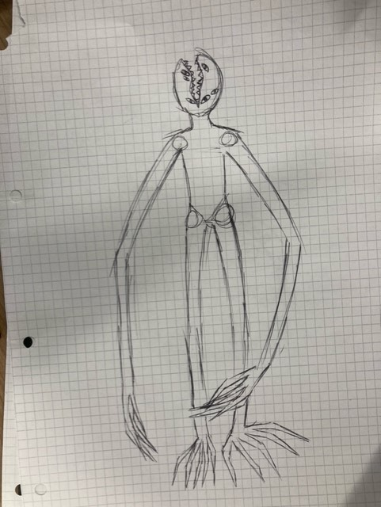

## Boss Behavior

The Beast (Boss/Pursuer/Tracker): The Beast will be the main terror of the game and the players ultimate enemy.

**Task and escort segments behavior:** The Beast will skulk throughout the environment of Teskaz and hint itself towards the player in vague and ominous either through the environment or via notes in the players Task list both will include visual and audio effects.

**Chasing segments behavior:** chasing segments of the game The Beast will pursue the player throughout the level using ai pathfinding and enemy ai. The Beast will be stunnable in the chasing segments if the player has the item broom/mop equipped and facing towards The Beast. If The Beast gets stunned it will run of into the dark wait for a bit, get the players position and then pursue once again. Once the player has either stunned or successfully stunned the enemy 4 times The Beast will run into the darkness and de-spawn.

# NPCs—

-Grandma, an old lady who got lost during the day and remained after closing. She jumps scares you accidentally, and then you must escort her out of the store as part of your job Tasks.

-The Beast, a hostile creature that wants you dead. You must avoid it whilst completing your tasks to beat the game.

- Middle-aged man, A middle-aged man that accidentally got locked in after closing. He attempts to find you and asks you to escort him out.

-Manager Ganbold, he is your manager. He leaves you a list of tasks and was the one who allowed you to take up the night shift.

The Figure above is the model for manager Ganbold NPC who will be leaving you tasks for your task list throughout the game.

This model will also be repurposed and modified for the Middle-aged man NPC who will be the other escort task NPC.

The Figure above is the model for the old lady NPC who the player will interact with during their escort task and who the player will share unnerving dialogue with dialog with.

# Minigames/puzzle—

**Restore Teskaz power mini game:** An Idea for an event that can accrue where the power to the store disconnects and must be reconnected after the chasing segment against The Beast. The minigame will be a simple turn to connect style of mini game where the power has a start and an end and in the middle has puzzle bits to rotate until they fit and lead from start to end. This will turn the power on once completed.

# Monetization—

The game (Teskaz) will have a set price based on how long the game is, what the set prices are for indie horror games that are similar in length as well as how technical the games systems are.

DLC will also be included in the monetization of the game.

# Downloadable content—

## Teskaz Black Friday Massacre –

Teskaz Black Friday massacre is a first-person horror survival with first person shooting elements.

This DLC will be a follow up to the ending of the main game of Teskaz and will see your character Alex return to the hit super store Teskaz on the night of Black Friday after surviving the horrors of the previous night. You come back to finish the job and stop the great plan of Teskaz.

# Music and SFX

* Footsteps
* Ambience (AC whirring, fridges and freezers buzzing, etc.)
* When picking up or putting down items
* The Beast jump scare.
* Cleaning
* Light switches
* Doors opening and closing.
* Light Flickering
* Flashlight switching on and of
* Beast sounds

# Other screens—

* **Credits**—

The figure above is the example credits for Teskaz.

The credit screen will scroll down listing all the rolls in the making of Teskaz along of the names of the people who contributed to the making of Teskaz. As the credits scroll down music will play in the background. A potential epilogue plays setting up the DLC for Teskaz.

# Appendix(es)

This is the place where long lists go, including player animation, enemy animation, sound effects, music, cutscene scripts, in-game text, and VO scripts.

## Production Plan (for prototype)

|  |  |  |
| --- | --- | --- |
| **Activity** | **Estimated Time Frame (Days)** | **Program(s) Used** |
| Implementing core mechanics into a prototype level | 23/11/23 - 28/11/23 | Unity, Visual Studio |
| Implementing non-core mechanics | 28/11/23 - 02/11/23 | Unity, Visual Studio |
| Creating and implementing 3D models | 02/11/23- 06/12/23 | 3DS Max, Blender, Unity |
| Creating the prototype levels | 06/12/23- 09/12/23 | Unity |
| AI and pathfinding for enemy and NPCs | 09/12/23 - 14/12/23 | Unity, Visual Studio |
| Creating and implementing UI elements | 14/12/23 - 15/12/23 | 3DS Max, Blender, Unity, GIMP, Photoshop |
| **Overall Time (Days):** | 22 |  |

Sicart, M. (2009) *The Ethics of Computer Games.* Cambridge, MA: MIT Press

Adams, E. and Dormans, J. (2012) *Game Mechanics: Advanced Game Design.* Available at: https://learning.oreilly.com/library/view/game-mechanics-advanced/9780132946728/ch01.html (Accessed: 22/11/2023)

Sicart, M. (2008) “Defining Game Mechanics”, *Game Studies,* 8(2), Available at: <https://gamestudies.org/0802/articles/sicart>

Blue Isle Studios (2013) *Slender: The Arrival* [Video Game]. Blue Isle Publishing.

Acid Wizard Studio (2017) *Darkwood* [Video Game]. Acid Wizard Studio.

*Copyright, Designs and Patents Act 1988, c. 30A.* Available at: <https://www.legislation.gov.uk/ukpga/1988/48/section/30A> (Accessed: 23/11/2023).

## Contributions

List of contributors: Mario Battiston, Tom Jones, Tobi Prais, Cass Mepham.

|  |  |
| --- | --- |
| Section | Contributors |
| Game Goals  -Game’s “high concept” | Mario,Tom,Cass,Tobi |
| Who, What, How?  - Demographic  - How | Tom,Cass,Tobi,Mario |
| Platform and Technical requirements | Mario |
| Story Overview | Tobi,Tom,Cass,Mario |
| Publisher concerns  - Legal Considerations  - Social Considerations  - Ethical Considerations | Cass |
| Title/Start screen | Tom |
| Loading screen | Cass,Tobi |
| Game camera | Tobi,Mario |
| Player inventory tools | Mario,Tobi,Tom,Cass |
| Combat  - Power-ups/state modifiers | Mario,Tobi,Cass,Tom |
| Health | Tobi,Mario,Cass,Tom |
| Achievements | Tobi,Mario,Cass,Tom |
| Collectibles/Object sets- | Tobi,Mario,Cass,Tom |
| Game progression outline | Tobi |
| World overview/level select/navigation screen | Tobi |
| Game levels | Tobi,Mario,Cass,Tom |
| Mechanics | Mario,Cass,Tom,Tobi |
| General enemy rules | Tobi,Mario,Cass |
| Bosses  -Boss Behavior | Tobi,Cass,Tom,Mario |
| NPC’s | Mario,Tom,Tobi,Cass |
| Minigames/Puzzle | Mario |
| Monetization | Mario |
| Downloadable content  - Teskaz: Black Friday Massacre | Tobi,Mario,Cass,Tom |
| Music and SFX | Tom |
| Other screens  -Credits | Mario |
| Concept Art  -Beast  -Posters | Tobi,Mario,Cass |
| Production Plan (for prototype) | Tom |

|  |  |  |  |
| --- | --- | --- | --- |
| Date | Subject | Participants | Length |
| 26/10/2023 | Discussion on Game ideas | Mario, Cass, Tobi | 2 hours |
| 02/11/2023 | Starting GDD, discussing general ideas on the project | Mario, Tom, Cass, Tobi | 4 hours |
| 06/11/2023 | Discussion on loading screens and fonts | Tom, Cass, Tobi | 1.5 hours |
| 09/11/2023 | Discussion on beat map, game flowchart and ethical considerations | Mario, Tom, Cass, Tobi | 2 hours |
| 15/11/2023 | General meeting on progression, discussion on concept art and sound | Mario, Tom, Cass, Tobi | 3 hours |
| 17/11/2023 | Meeting on progress, discussion on ethical, social and legal impacts | Mario, Tom, Cass, Tobi | 1 hour |
| 22/11/2023 | Meeting on game levels, minutes added, section on mechanics, production plan. | Mario,Tom, Cass, Tobi | 1.5 hours |
| 23/11/2023 | Meeting on loading screens, minutes added, concept art added, npc models, Harvard referencing, layout adjustments, credits, contributions. |  |  |

# Concept art

## Beast

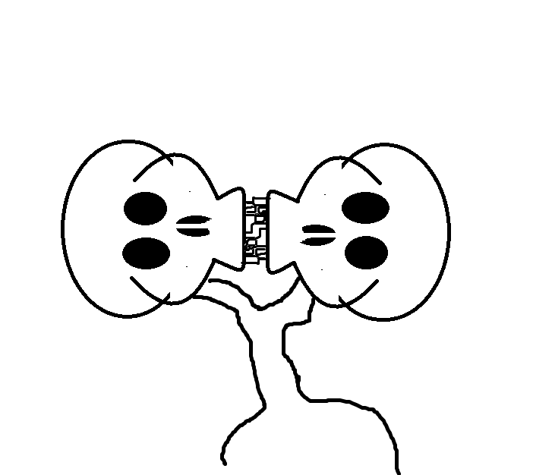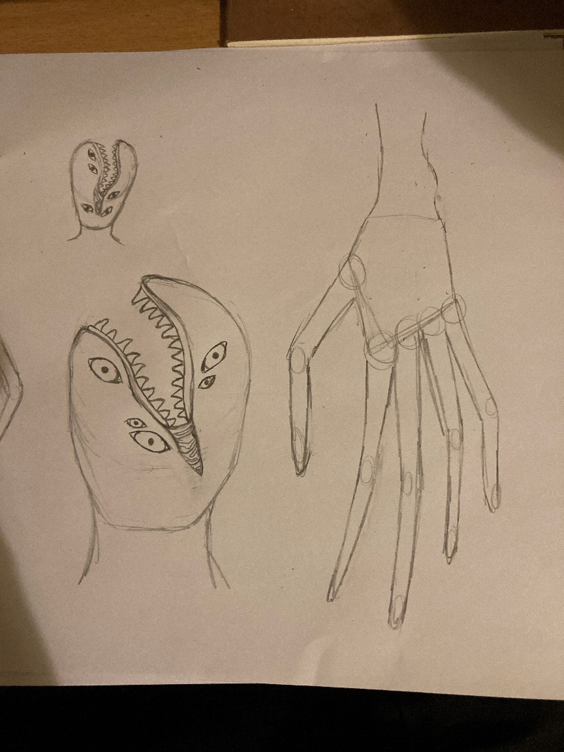

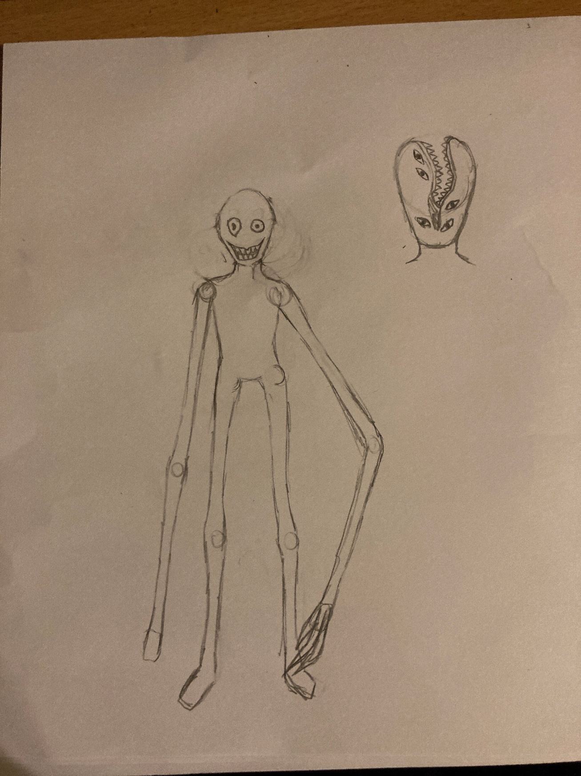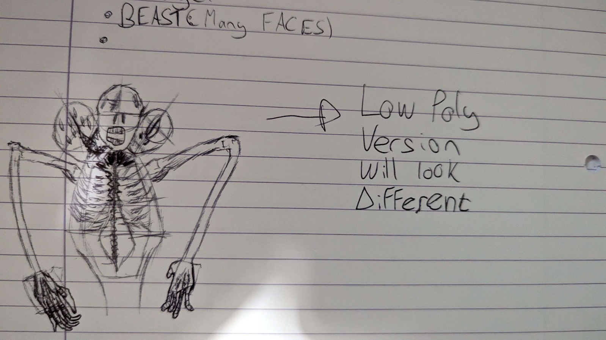

## Posters

## 



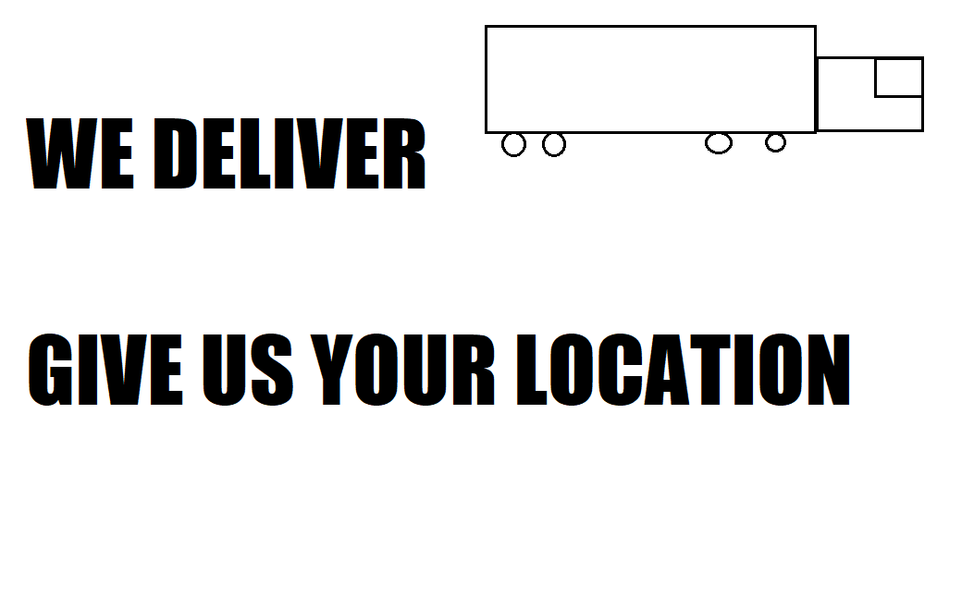



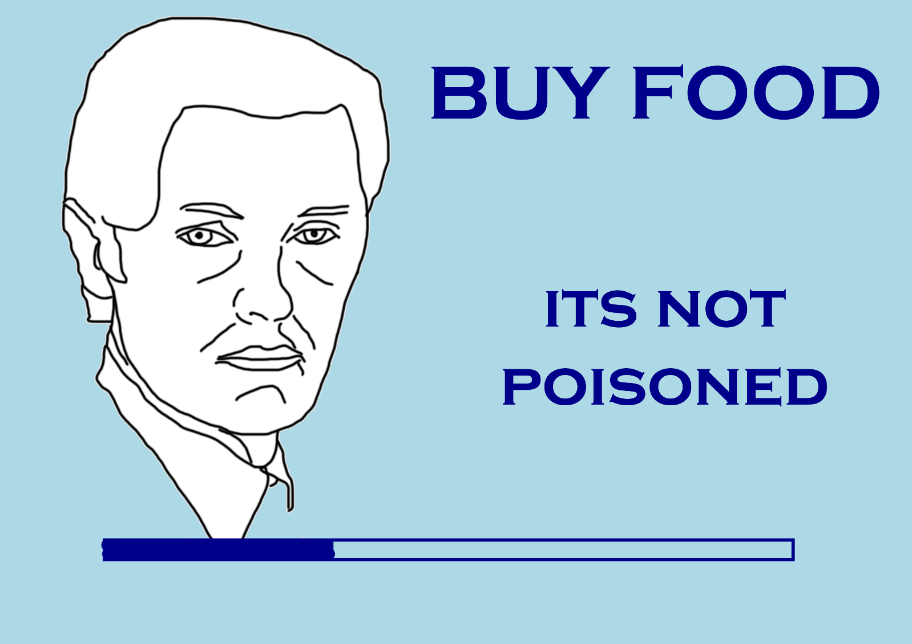

## Summoning circle

